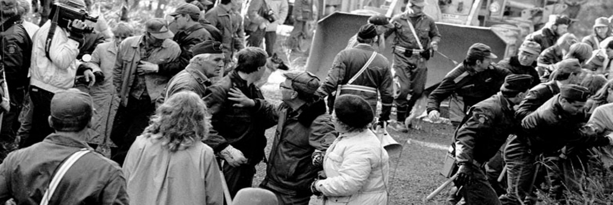
School of Geological Disposal
Strategies and communication for consent-based siting
From resistance to resonance: Communicating nuclear
waste management over five decades
This course offers a unique opportunity to learn how SKB’s have strategically built public trust
around one of Sweden’s most complex and long-term societal challenges
- the management of nuclear waste.
Gain insight into SKB’s siting process and communication journey, from the early studies in the 1970s through the study sites, feasibility studies, site investigations, licensing and forward to today. Discover the strategies, decision-making processes and engagement methods that helped transform
initial resistance into acceptance and, ultimately, long-term resonance.
We will explore:
- Strategies
- Who we communicated with
- How we engaged and involved stakeholders
- What we learned — and the key factors behind our communication success
You’ll also hear from the former Mayor of the Municipality of Östhammar, who will share the municipality’s perspective on SKB’s work. He will reflect on how the municipality engaged with residents and other stakeholders throughout the process, and how trust and transparency were built over time.
Online course
Period | March 18 – April 29, 2026 | Price | EUR 2300
Content | 9 pre-recorded presentation modules and possibility to raise questions to SKB experts. Opening and closing webinars, as well as two intermediate Q&A webinars. | Register | Go to www.skbinternational.se for full course details and registration

